**Intern FAQ**  
  
**Can I do a paid internship?**  
- LPK does not offer paid internship because it is a non profit organization and cannot finance such positions.   
  
**Do I need to speak Swahili?**  
-No! But you will find that preparing by learning even some basic phrases will be a huge help while you are here!  
  
**I can’t afford to come there, can I still fundraise for a project or program?**  
-Absolutely! If you are unable to come work on the ground with us at LPK but have a passion for a specific project you can fundraise in your local community and support a specific project of your choosing.  
  
**How long are the internships?**  
- Your length of stay is whatever you are available for and can be decided on an individual basis. A minimum of 4 weeks is recommended to ensure you are able to experience all that LPK has to offer and to give you time to work on your project.  
 **Where is LPK?**  
LPK is located in Ngong Town which is approximately 40km from Nairobi airport.

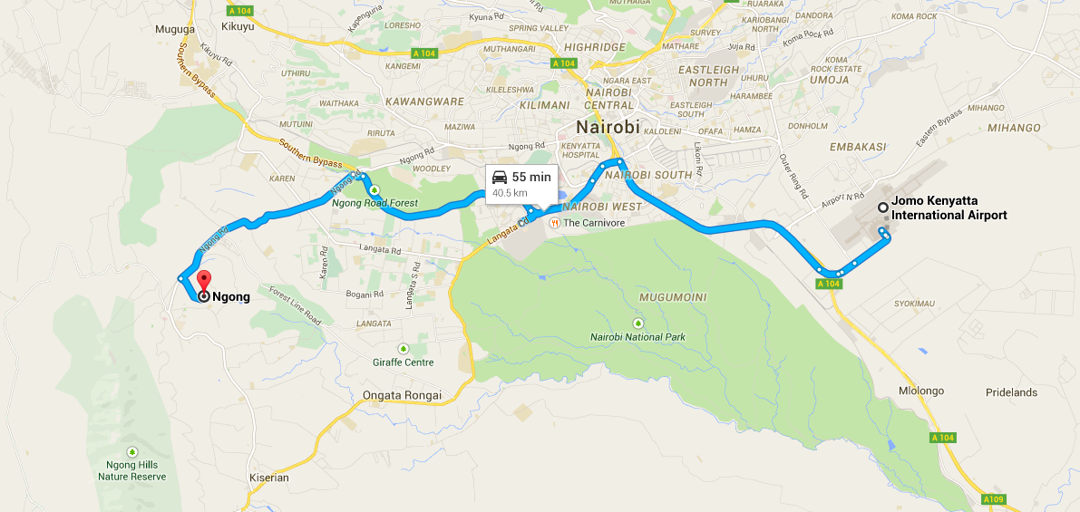  
  
  
**Where can I stay?**  
-Depending on the size of group and availability, accommodation can be provided at the intern house which is located in the same building as Mum’s home in nearby Matasia. You are also welcome to seek out your own accommodation in the area.

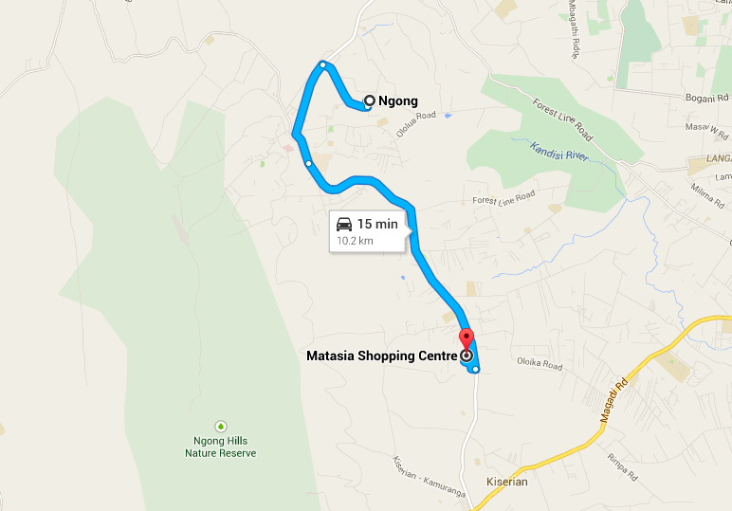  
  
**What are the costs associated with interning?**  
- The costs of interning will come from your accommodation,& food, flights, and daily transportation to and from work. There is a daily rate to stay at the LPK Intern house which includes breakfast and supper.  
Also factor in any sightseeing or additional trips you want to make while in country.   
  
  
**How do I get to work each day?**  
- You can easily get to and from the office and projects each day using the Matatu from the apartment or if you choose accommodation right in Ngong Town you can easily reach it by foot. *see end of document for instructions to get to the office from the Matatu terminal in Ngong.   
  
**What will the funds I raise go to?**  
-If you have raised money prior to internship you can discuss the projects and programs you wish to fund.   
  
**Can I come volunteer alone? Is it safe?**  
-LPK welcomes both individuals and groups to come and volunteer and accommodation and travel are absolutely safe for individuals. Although Ngong may be referred to as being an outlaying area of Nairobi it is far from the busy capitol and offers a beautiful safe area to experience what LPK and Kenya have to offer.   
  
**What can I do to prepare for the trip?**  
-Take the time to research the local Culture and climate so you know what to expect and also to plan how to spend your spare/extra time. It is recommended that you visit your local travel clinic to discuss vaccinations etc. prior to coming. For more information on what to pack and how to prepare, visit <http://travel.gc.ca> for Canadian information  
  
If you have any other questions or concerns please do not hesitate to contact the office at [livingpositivekenya@gmail.com](mailto:livingpositivekenya@gmail.com) We can’t wait to hear from you!  
  
  
Getting around the hub of Ngong Town is quite easy. Once you arrive via Matatu you will cross the street and go left towards Barclays Bank. Cross the road and go right up the road(it will be slightly uphill). Continue until you reach a large alley on the left just before the street forks(Look for “lighting up africa”?). You will go down the alley and continue straight alongside the large building on your left. You will see a small peach coloured building ahead on the left, this is your destination!   
  
 If you stick to the main road and miss the alley keep following the main road left and it will keep going and curving to the left. You will eventually see a bright red green and white “TNA” building. Follow the little dirt road left directly before walking past this building. You will see LPK’s building straight ahead.  
  
